July 2nd, 2006
Nadine, Gavin and Leonie,
Well, it is now four weeks since I came back from the hospital. My last formal appointment was the doctor’s visit last Tuesday though there is a follow-up appointment in a few weeks. The wounds are healing quite nicely and I no longer have dressings on any on them, though when going to the gym I had been covering the foot with a sock. I still do not have full movement hack in my right hand though I am now able to do all the exercises with the weights in the gym.

To enable me to write these letters, I keep a computer desktop diary. It is interesting that for the past month, there was an entry for every day. I think that it the first time that has happened.
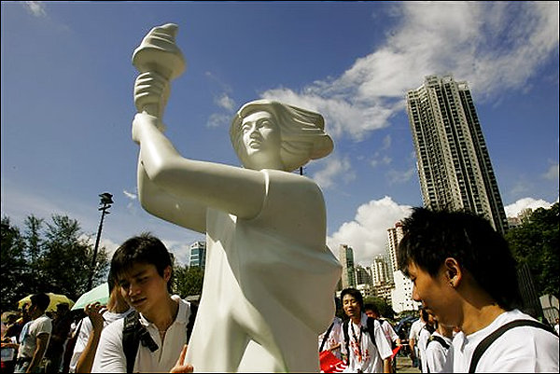




Yesterday was a public holiday for China’s National Day and for the handover anniversary. There was the now usual ‘democracy rally’ held in the afternoon. Estimates ranged from 28 000 (from the Police who always seem to underestimate) to 58 000 (from the organisers, who probably always over-estimate). Not quite the half million who took part a few years ago. This year there was an opposing pro-China/government rally, held in the morning, which started with a concert at the Hong Kong stadium and continued later down the streets with bands, Chinese dragons and lion dancers. Estimates were about 40 000, probably because of the free concert! The photographs show shots from each camp. See if you can figure out which is which. (Answers at the end on the letter!)
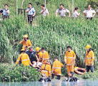
The other day, near here, a hawker drowned in the Tin Shui Wai river (more like a nullah!) while trying to escape arrest from hawker control officers who were chasing him. He jumped over the fence and into the ‘water’ even though he could not swim. None of the officers could swim either, and if the reports are correct, just stood there watching him drown. This is the second death from a hawker trying to escape. A few months ago, a hawker was hit by a vehicle while running across a road.

Yesterday also saw the implementation of many more no-smoking rooms here. All the rooms on alternate floors are now designated as non-smoking. Fortunately, this floor is one of them, otherwise I would probably have moved. So yesterday, non-smoking signs appeared in the corridors and little signs were placed in each room.
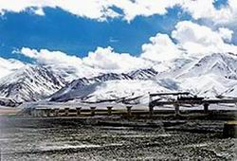

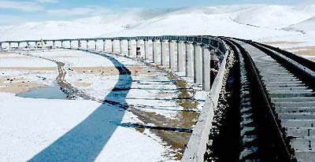

Yesterday seems to have been a busy day! The completed railway from Beijing to Tibet was officially opened. It is about 1400 km long and takes about 2 days and nights. The construction of the railway actually began in the ‘50s and it was only the final third that needed to be completed, which took the last few years. It certainly seems to be spectacular and I would like to do it sometime. Because it rises to over 5000 m (about 17 000 feet), where the air is very thin, each compartment is provided with oxygen vents. However, it was mentioned in the news reports that smoking is allowed. I think that is a disaster waiting to happen. If oxygen bits a burning cigarette, it is likely to explode and ignite other things in the compartment. (Think of the disaster with Apollo 1 in the NASA moon programme in the ‘60s while it was still on the ground. The capsule was filled with pure oxygen and an accidental spark caused the inside of the capsule to erupt in a fireball killing the 3 astronauts in seconds. Since then, they have not use pure oxygen in the capsules.)




Sent some copies of corrected proof copies of books to Singapore. I was following the progress on the company’s internet tracking system. When the package arrived, it seemed to have been received by a person called Mr/Ms Ko as the name Co Chop was written. It occurred to me later that this probably actually meant ‘company chop’!!

A new report in Hong Kong shows that most primary school 'tuck' shops sell unhealthy snack foods and drinks. So, again, lay off these foods, and especially soda drinks, which you should stop drinking completely.
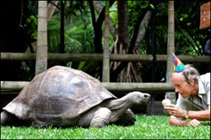
Did you hear that Harriet, the Galapagos tortoise brought by Darwin, died aged about 175 years? Five years after Harriet was born, Charles Darwin visited the Galapagos. He took three tortoises back to England with him: Tom, Dick, and Harry. For many years, scientists thought that Harriet was male (it's hard to tell with tortoises). Some claim that Harriet, once known as Harry, was among Darwin's tortoises. Eventually, it ended up in Australia. The all-time age record for an animal seems to be 188, set by another Galapagos land tortoise, the personal pet of the King of Tonga.
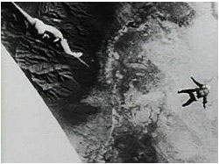
It was 46 years ago, in 1960 that man first ascended to the lower edges of space. This was in a balloon that reached an altitude of 102 800 feet. The pilot then jumped out and parachuted safely back to Earth. On the way down, he broke the sound barrier with his body (because there was little air at first to slow him down) and set a freefall record that still stands today. The photo shown, taken by a camera in the balloon gondola as he jumped, was transmitted back to Earth.
That seems to be it for now.

Cheers
Answers: Democracy rally –right. Pro-China rally – left.

